Cumulative LandXML-1.0 changes since LandXML-0.88

Lastest Draft changes (6/04/2002) NOT Posted:

Added an optional <Zone>.<ZoneCrossSectStucture> element to model 3D structures associated with the road model. This definition allows the modeling of 3D structures extruded along the roadway such as retaining walls, storm water channels, longitudinal barriers (Jersey Barriers) and bridge abutments:

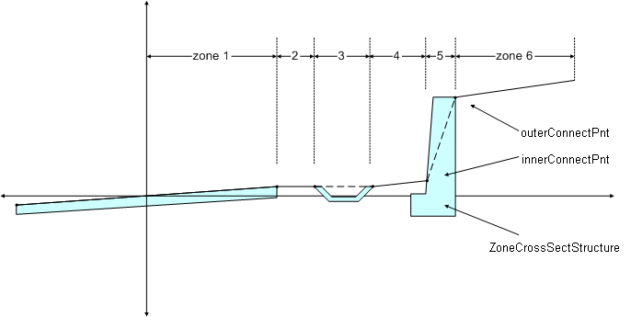

Where the shaded area represents the cross-sectional shape of the retaining wall. The innerConnectPnt and outerConnectPnt values are related to the adjacent zones OR may be free floating location based on its placement relative the road centerline. See the LandXML Guidelines document for more details.

Added new values, some supporting the new <ZoneCroosSectStructure> element, to <Zone>.zoneCategoryType, which indicates the specific kind of object the Zone represents:

<xs:enumeration value="channel"/>
<xs:enumeration value="bike facilities"/>
<xs:enumeration value="obstruction offset"/>
<xs:enumeration value="longitudinal barrier"/>
<xs:enumeration value="sound barrier"/>
<xs:enumeration value="bridge abutment"/>
<xs:enumeration value="vertical pillar"/>

Added new simple types offsetDistance and offsetElevation to clearly indicate the specialized meaning when expressing 2d perpendicular distance from road centerlines
coordinate geometry, profile origins or from cross section origins.
Removed redundant sub-elements <PntList2D> and <PntList3D> from <PlanFeature> since the contained <CoordGeom> element can now model both using the <CoordGeom>.<IrregularLine> or <CoordGeom>.<Chain> elements.

Replaced all instances of <xs:any> with <xs:any namespace="##any" processContents="skip"/> to allow freeform XML/text content and still validate according to XML schema and XSLT specifications.

Removed <Guardrail> and <RoadLighting> elements from the <Roadway> element. Also removed the associated simpleTypes: guardrailType, guardrailEndType, and roadLightType . These need further refinement and development and should be replacec with general roadside hardware definition using a reference code or id to a know standard.

Renamed attribute <RoadSign>.MTUCDCode to the correct spelling <RoadSign>.MUTCDCode from the standard FHWA “Manual on Uniform Traffic Control Devices”.

Added new <Chain> element type to <CoorGeom>. A <Chain> is defined as: A text value that is a space delimited list of CgPoint (and other PointType derived elements) names that form a linear connected chain.
example: <Chain>1 23 45 34</Chain>
represents a linear connection between CgPoint name 1, 23, 45 and 34.

Replaced <CoorgGeom>.cgPointsRefs with the new<CoorgGeom>.<Chain> element type.

Replaced <Surface>.<Definition>.<CgPointList> with <Surface>.<Definition>.<Chain>.

Replaced the <CgPointList> type with the new <Chain> element.

Added <xs:attribute name="timestamp" type="xs:dateTime" use="optional"/> to the <Application> and <Author> elements. This allows apps to time stamp a new additional information to an existing LandXML file or data stream.

Changed <ZoneWidth> width attribute width to separate startWidth and endWidth attributes to specify width transitions.

Corrected spelling errors: "xxCordianteSystemName" should be "xxCoordinateSystemName" in the <CoordinateSystem> comment and
"countour" should be "contour" in the <xs:simpleType name="DTMAttributeType"> enumerations.

Moved <Corrections> attributes to the <SurveyHeader> that are project specific, scaleFactor, applySeaLevelCorrection, applyAtmosphericCorrection, temperature, pressure, and added new seaLevelCorrectionFactor and combinedFactor attributes.

Added to <CgPoint>
<xs:attribute name="surveyHorizontalOrder" type="xs:string"/>
<xs:attribute name="surveyVerticalOrder" type="xs:string"/>

Made DocFileRef part of Choice in <Feature> element.

Added to <CoordinateSystem> : <xs:attribute name="fileLocation" type="xs:anyURI" use="required"/> to record the file location of the external coordinate system definition.

Added horizontalPrecision and verticalPreceision attributes to <GPSVector> as double values and would represent the computed expected horizontal and vertical precisions for the point fixed by the GPS vector, in the same units as the vector components.

Added base type for all GPS time attributes:

<xs:simpleType name="GPSTime">
<xs:annotation>
<xs:documentation> GPS Time = Nbr of GPS weeks * 604800 (seconds in a week) + seconds in GPS week.</xs:documentation>
</xs:annotation>
<xs:restriction base="xs:double"/>
</xs:simpleType>

Split GPSAntennaDetails into GPSAntennaDetails and GPSRecieverDetails.

<xs:element name="GPSReceiverDetails">
<xs:annotation>
<xs:documentation/>
</xs:annotation>
<xs:complexType>
<xs:sequence>
<xs:choice minOccurs="0" maxOccurs="unbounded">
<xs:element ref="FieldNote" minOccurs="0" maxOccurs="unbounded"/>
<xs:element ref="Feature" minOccurs="0" maxOccurs="unbounded"/>
</xs:choice>
</xs:sequence>
<xs:attribute name="id" type="xs:ID" use="required"/>
<xs:attribute name="manufacturer" type="xs:string"/>
<xs:attribute name="model" type="xs:string"/>
<xs:attribute name="serialNumber" type="xs:string"/>
</xs:complexType>
</xs:element>

Added optional fixed reference <Monument> element under GPSDetails.

Added GPSDetails latitude, longitude, altitude, ellipsiodnal, and orthometric height.

<Backsight> made id and azimuth attributes optional.

<TargetSetup> made id, targetHeight optional.

<ControlObservation> renamed <ControChecks> that represent reference or check shots to known locations during survey field observations.

<RawObservation> add an ‘unused’ boolean attribute to indicate the record is not used. Add directFace attribute to indicate the scope is flipped – true if the scope is not flipped, false if it is.

Add azimuth attribute to <RawObservation> and replaced <LaserObservation> with
<RawObservation>.

<GPSVector> add startTime, stopTime of type GPSTime as optional attributes.

Added optional pntRef attribute to <GPSPosition>.

LandXML-1.0.xsd posted 04-01-2002: Schema Changes since January 31, 2002

Final LINZ changes:

Added new values to the following enumerations: equipmentType, monumentCondition, monumentPurpose, monumentState, monumentType, observationType, parcelClass, parcelStateType, surveyType

Removed the duplicate name attribute from <CgPoint>. The name attribute is part of the base type <PointType> from which <CgPoint> is derived.

New additions for FHWA IHSDM interoperability

Added optional <Superelevation> element to <Alignment> that models the critical superelevation stations.

<Alignment>.<Profile>.<ProfAlign> must now begin and end with a <PVI> element.

<RoadWays>. <RoadWay> data structure added.
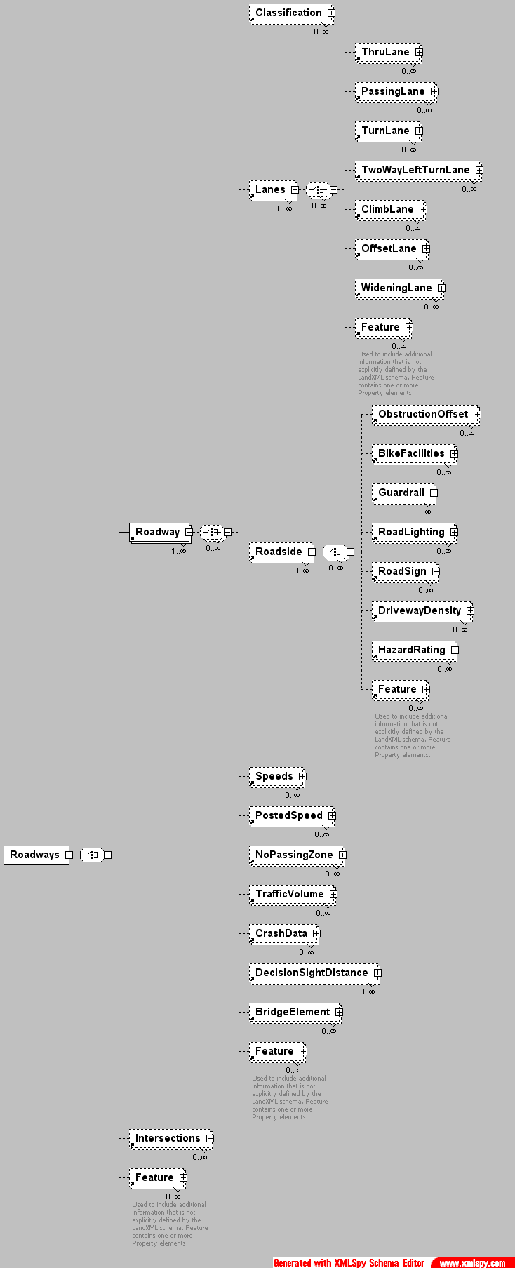
The <GradeModel> has been modified to better describe road top and sub-surfaces.

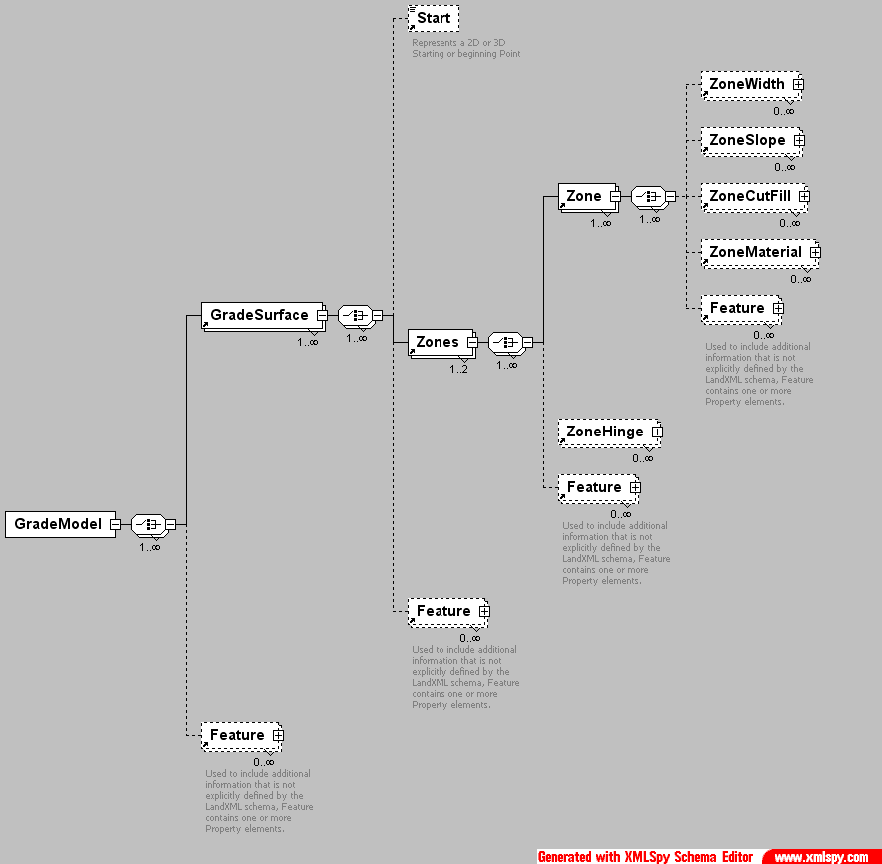

LandXML-1.0.xsd Schema Changes since October 24, 2001

The Following LandXML schema change notes have been categorized and appear in priority order.

Application Implementation Notes

Even though there have been significant changes to the LandXML-1.0 schema, instance data built from previous drafts of LandXML-1.0 should still validate.

Applications supporting LandXML-0.88 instance data can be upgraded quickly by keeping the following in mind.

- Support must be added for the new <Angular> and <Directional> units.
- Additional support for OpenGIS common use coordinate systems has been added to the <CoordinateSystems> element.
- Code that handles <Parcel> elements should look for nested <Parcel> elements. Nesting of <Parcel> elements allows for implied geometric containment.

There are a number of new capabilities that have been added, such as the ability to associate external data (using URI) to any element that contains a <Feature> element. Using the new <DocFileRef> element, it is easy to associate external data, such as raw data files, drawing files, project files, legal documents or even web data references such as links to DEM and other surface data, to specific elements.

Namespace Changes

Removed lx: namespace prefix and changed namespace definition to:
<xs:schema targetNamespace="http://www.landxml.org/schema/LandXML-1.0" xmlns:xs="http://www.w3.org/2001/XMLSchema" xmlns="http://www.landxml.org/schema/LandXML-1.0" elementFormDefault="unqualified" attributeFormDefault="unqualified" version="1.0" id="LandXML-1.0.xsd">

This namespace form follows industry best practices for schema development.

Element Uniqueness Enforcement

Unique names now resolve using simple xpath syntax and instance data will validate as of XMLSpy version 4.2. Unique “name”, “id” and “sta” attributes are scoped to element types and collections of element types. It has been agreed that this form over ID/IDREF form is better suited to our needs.

<xs:selector xpath="CgPoints/CgPoint"/>
<xs:field xpath="@name"/>

<xs:selector xpath="Monuments/Monument"/>
<xs:field xpath="@name"/>

<xs:selector xpath="Surfaces/Surface"/>
<xs:field xpath="@name"/>

<xs:selector xpath="Surface/Definition/Pnts/P"/>
<xs:field xpath="@id"/>

<xs:selector xpath="Parcels/Parcel"/>
<xs:field xpath="@name"/>

<xs:selector xpath="Alignments/Alignment"/>
<xs:field xpath="@name"/>

<xs:selector xpath="PipeNetworks/PipeNetwork"/>
<xs:field xpath="@name"/>

<xs:selector xpath="PipeNetwork/Pipes/Pipe"/>
<xs:field xpath="@name"/>

<xs:selector xpath="PipeNetwork/Stucts/Struct"/>
<xs:field xpath="@name"/>

<xs:selector xpath="CrossSect"/>
<xs:field xpath="@sta"/>

For example, the following is NOT allowed:
<CgPoints name=”topo shots”>
<CgPoint name="221">112.20158756 -42.24299875</CgPoint>
<CgPoint name="221">110.93558099 57.71138949</CgPoint>
</CgPoints>
nor is this allowed:
<CgPoints name=”topo shots”>
<CgPoint name="221">112.20158756 -42.24299875</CgPoint>
<CgPoint name="222">110.93558099 57.71138949</CgPoint>
</CgPoints>
<…>
<CgPoints name=”EP shots”>
<CgPoint name="221">112.20158756 -42.24299875</CgPoint>
<CgPoint name="222">110.93558099 57.71138949</CgPoint>
</CgPoints>

Each <CgPoint>.name value must be unique with the data file, but may be the same value as an <Alignment>.name value with in the same data file.

Example:

<CgPoints name=”topo shots”>
<CgPoint name="221">112.20158756 -42.24299875</CgPoint>
<CgPoint name="222">110.93558099 57.71138949</CgPoint>
</CgPoints>
<…>
<Alignments name=”existing CL”>
<Alignment name="221">
<…>
</Alignment>
</Alignments>

This is perfectly valid. LandXML Element uniqueness has data context scoping and is not data file scope global which is less restrictive than using ID, IDREF built-in XML Schema data types.

Element Referencing Changes

The following simpleTypes have been added to make LandXML element ‘name’ attribute referencing less ambiguous.

"pointNameRef" "pointNameRefs"
"alignmentNameRef" "alignmentNameRefs"
"surfaceNameRef" "surfaceNameRefs"
"parcelNameRef" "parcelNameRefs"
"coordGeomNameRef" "coordGeomNameRefs"
"pipeNameRef" "PipeNameRefs"
"structNameRef" "structNameRefs"
"monumentNameRef"
"waterShedNameRef"

For example consider the <CgPoint> and other <PointType> derived elements:

<xs:complexType name="PointType" mixed="true">
<xs:simpleContent>
<xs:restriction base="Point">
<xs:minLength value="0"/>
<xs:maxLength value="3"/>
<xs:attribute name="name" type="xs:string"/>
<xs:attribute name="desc" type="xs:string"/>
<xs:attribute name="code" type="xs:string"/>
<xs:attribute name="state" type="stateType"/>
<xs:attribute name="pntRef" type="pointNameRef"/>
<xs:attribute name="pointGeometry" type="pointGeometryType"/>
<xs:attribute name="DTMAttribute" type="DTMAttributeType"/>
<xs:attribute name="timestamp" type="xs:dateTime" use="optional"/>
<xs:attribute name="role" type="surveyRoleType" use="optional"/>
</xs:restriction>
</xs:simpleContent>
</xs:complexType>

The “pntRef” attribute is now of type “pointNameRef”, which is less ambiguous than the previous definition of type “string”. That is the value of “pntRef” should indicate a “name” attribute in a <PointType> derived element.

Coordinate System Support

New "xxCoordianteSystemName" attributes were gather from the OpenGIS Coordinate System interface descriptions and the values of the names should be the OpenGIS common use name for the coordinate system. The OpenGIS coordinate systems XML description may still be appended to this element and validate."

<xs:element name="CoordinateSystem">
<xs:complexType>
<xs:sequence>
<xs:element ref="Start"/>
<xs:element ref="Feature" minOccurs="0" maxOccurs="unbounded"/>
<xs:any processContents="lax"/>
</xs:sequence>
<xs:attribute name="desc" type="xs:string"/>
<xs:attribute name="name" type="xs:string"/>
<xs:attribute name="rotationAngle" type="angle"/>
<xs:attribute name="datum" type="xs:string"/>
<xs:attribute name="horizontalDatum" type="xs:string"/>
<xs:attribute name="verticalDatum" type="xs:string"/>
<xs:attribute name="ellipsoidName" type="xs:string"/>
<xs:attribute name="fittedCoordinateSystemName" type="xs:string"/>
<xs:attribute name="horizontalCoordinateSystemName" type="xs:string"/>
<xs:attribute name="compoundCoordinateSystemName" type="xs:string"/>
<xs:attribute name="localCoordinateSystemName" type="xs:string"/>
<xs:attribute name="geographicCoordinateSystemName" type="xs:string"/>
<xs:attribute name="projectedCoordinateSystemName" type="xs:string"/>
<xs:attribute name="geocentricCoordinateSystemName" type="xs:string"/>
<xs:attribute name="verticalCoordinateSystemName" type="xs:string"/>
</xs:complexType>
</xs:element>

Survey Related Changes

Added optional "timestamp" attribute to <PointType>. Used to record a time using the XMLSchema ‘dateTime’ simple type.

Added optional "role" attribute to <CgPoint> of type “surveyRoleType”.
The idea behind the "role" attribute is the question "What role does a certain point play within its context (stake-out-process or every other survey)?". The following values for "role" are enumerated in the “surveyRoleType” simpletype as measured, to stake out, staked out, calculated, assistance point, user entered point, control point.

Added optional <CgPoints> top <Survey>. This allows for an implied relationship to the survey data with the <Survey> element.

Added the <Feature> element to all elements derived from <PointType> which includes <CgPoint>. Also added to <Surface>.<Boundary> and <Surface>.<SourceData>.<Contours>.

Added an optional “coordGeomRef” to all <Survey> observation elements allowing a particular survey observation element to reference a specific <CoordGeom> element. This allows linking specific observations to named <Parcel>.<CoordGeom> definitions. This can be any <CoorGeom> containing element, including <Alignment> elements.

Expanded the enumeration value types for the following simpleTypes:
equipmentType, monumentCondition, monumentPurpose, monumentState, monumentType, observationType, parcelClass, parcelStateType, surveyType.

General Changes

Many comments have been added to clarify the meaning or intended use of elements and attributes.

Changed the <LandXML> element sequence “sequence” to “choice” for sub element content. This allows for out-of-order sequencing of elements contained immediately under <LandXML> the node. Specifically the required elements no longer need to appear before optional elements.

Removed <CgPointList> from <LandXML>.

Changed <Spiral>.theta type to "lx:angle" to be more specific.

Changed <Surface>.<SourceData>.<DataPoints> type to type <PointList3D>.

<GradeModel> now uses the new name referencing scheme – IDREFS are no longer used for alignment and surface referencing.

Added the sub element <DocFileRef> to the common <Feature> element. Using this new element, it is easy to associate external data, such as raw data files, drawing files, project files, legal documents or even web data references such as links to DEM and other surface data, to specific elements.

Added an optional “alignmentRef” attribute of type alignmentNameRef to the <PipeNetwork> element. This allows a relationship specification to a particular <Alignment> definition.

LandXML 1.0 Schema Changes Since October. 15, 2001

Changes reflected in the September 24, 2001 posting of LandXML-1.0

Changed the LandXML namespace to http://www.landxml.org/schema/LandXML-1.0.

Added "angularUnit" and "directionUnit" to <Units> element.
Example:
<Units>
<Imperial linearUnit="foot" areaUnit="squareFoot" volumeUnit="cubicYard" temperatureUnit="fahrenheit" pressureUnit="inHG" angularUnit="radians" directionUnit="radians"/>
</Units>

Renamed simpleType definition "AngularType" to "angularType".

Changed <SurveyHeader>.<MapPoint> to allow multiple instances.

Bearing / Azimuth - As bearing is now understood to be azimuth, the attributes related to this need to be renamed to azimuth. i.e. bearingAccuracy -> azimuthAccuracy, adoptedBearingSurvey -> adoptedAzimuthSurvey, and bearingAdoptionFactor -> azimuthAdoptionFactor.

Observation attributes – Added AzimuthAccClass and DistanceAccClass attributes to the ReducedObs and BearingAccClass and LengthAccClass to the ReducedArcObs elements as String types. This means that observations can have both a numeric accuracy as well as an accuracy classification within the survey (eg Class 1, Class 2 ...etc).

LandXML 1.0 Schema Changes Since 7-10-2001

Changes reflected in the October 15, 2001 posting of LandXML-1.0

- Added <Angular> element to <Units>. Valid values are radians, grads, decimal degrees, and decimal dd.mm.ss. The default value is radians unless otherwise specified.
- Renamed SimpleType “point” to “Point”.
- Removed “bearing” attribute from <ReducedObservation>.
- Renamed <ReducedObservation> attributes bearingClass, distanceClass and observationClass to bearingType, distanceType and observationType.
- Added optional <MapPoint> element to <Survey>.<SurveyHeader> to allow for general location of survey data.
- Renamed <InstrumentDetails> attribute “makeAndModel” to “manufacturer” and added a separate “model” attribute.
- Added <DataPoints> to <Surface>.<SourceData> element to allow random point collections as source data for the surface.
- Changed <Surface>.<Definition>.<Faces>.<F> element type to specify a list of 3 integer values each integer mapping into one <Surface>.<Definition>.<Pnts>.<P>.id attribute.
- Changed derivation from “Point” to “PointType” for the following elements:
  - <CgPoint>
  - <P>
  - <PVI>
  - <Outlet>
  - <RetWallPnt>

This means that any <PointType> derived element can refer to any other <PointType> derived element by specifying the pntRef attribute containing the “name” value of the point.

<CgPoint name="221" desc="concrete mon CRX-21">112.20158756 -42.24299875 124.567</CgPoint>
<CgPoint name="222" desc="tree">110.93558099 57.71138949</CgPoint>
<CgPoint name="223" desc="tree">14.08567077 85.54679033</CgPoint>
<CgPoint name="224" state="existing">-15.03259906 -52.99758544</CgPoint>
<CgPoint name="232" pntRef="221"/>
and
<Surface name="FG" desc="from 3d grid">
<Definition surfType="TIN" area2DSurf="2768515.7662" area3DSurf="3348805.6532" elevMax="1403.5660" elevMin="1150.0000">
<Pnts>
<P id="1">2289.759524 1968.519967 1283.2337</P>
<P id="2">2263.776071 2011.238349 1283.9169</P>
<P id="3" pntRef="221"/>

Schema Changes Since LandXML-0.88

Changes reflected in the July 10, 2001 posting of LandXML-1.0
- Added optional <Units> support to <Pipes> and <Structs> elements.
- Added optional diameterUnit, widthUnit, heightUnit, velocityUnit, and flowUnit to <Units> in order to support clearer hydraulic unit types.
- Added a <PlanFeatures> element to hold generic features, such as building footprints or wetlands.
- Added explicit type="string" to attributes such as name and description.
- Removed use="optional" from optional attributes as it is the default.
- Removed numerous comments that were no longer necessary.
- Added min of 2, max of 3 restrictions to all 2D/3D points.
- Changed LandXML.xsd schema namespace to http://www.w3.org/2001/XMLSchema
- Changed version to "1.0" and namespace to http://www.landxml.org/schema/LandXML-1.0/LandXML-1.0
- Reorganized the order of the elements within the file to more closely match the logical order of the data structure.
- Added <Parcels> collections in the <Parcel> element for nesting parcels.
- Renamed <CgPointType>::order attribute to <CgPointType>::surveyOrder.
- Removed starting “/” from select strings in the unique xpath statements.
- Renamed "officialIdentifier" to "oID" and added it to the following elements:
  - <Surface>
  - <Alignment>
  - <PipeNetwork>
  - <Struct>
  - <Pipe>
- Renamed <CgPointType>::order attribute to <CgPointType>::surveyOrder.
- Added type="string" to the following attributes;
  - name
  - desc
  - code
  - pntRef
  - parcelType
  - owner (Parcel element)
  - taxId (Parcel element)
- Removed use="optional" from all attributes. “optional” is the default for attributes.
- Removed most of the comments, such as attribute headers that divided required and optional attributes (see below)

LINZ Changes:
- Added new root elements to <LandXML>, <Monuments> collection of <Monument> elements and <SurveyMonument> for survey monument records. This relates the new monument element to a survey - indicating its purpose in the survey and distrubed / replaced info as well.
- Added new enumeration types <MonumentType>, <MonumentCategory>, <MonumentCondition>, <BeaconType>, <BeaconProtectionType>, <PurposeType>,
- Added <IrregularLine> element to <CoordGeom>::
- Added optional OfficialID attribute to <CgPointType> [<CgPoint>, ], <Monument>, <Line>, <Curve>, <Spiral>, <IrregularLine>, <Parcel>::
- Added <Monument> key and <SurveyMonument> keyref elements.
- Added optional <CgPointType>::surveyOrder attribute.
- Added optional <Parcel>::<Title> element.
- Added attributes: "equipmentUsed", "bearingAccuracy", "distanceAccuracy", "date", "bearingClass", "distanceClass", "adoptedBearingSurvey", "adoptedDistanceSurvey", "bearingAdoptionFactor", "distanceAdoptionFactor” To <RawObservation>::
- Added <RawArcObservation> element.

